Date: 9/9/2019

Time: 3.30pm

Venue: SOB GSR 3-21

Attendees: All except Rachel

Agenda: 1. Do up logic for BIOS in preparation for sprint 1

**For Login:**  
Php files:

1. Login.php
2. Process_login.php
3. AccountDAO.php
4. Account.php + phpMyAdmin

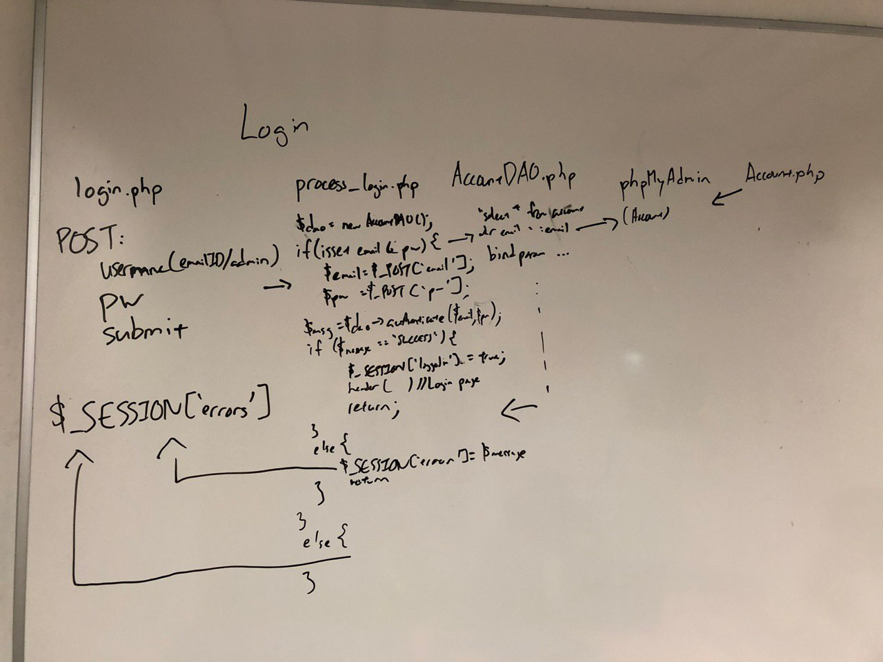

Updated( 4.37pm):

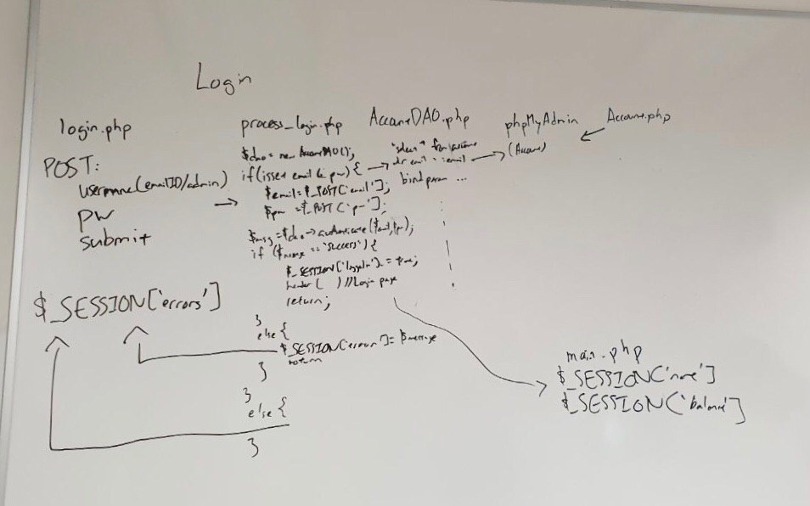

**For bidding:**

Account.php is a constructor  
Some courses in course.csv may not be available in section.csv

→ must first check if they tally

Assumption : bidding one course at a time

For bidding a course need to ensure:

* Student has not taken it before
* Has met the pre-quisites
* Cannot bid diff sections for same course

Updated( 5.30pm):

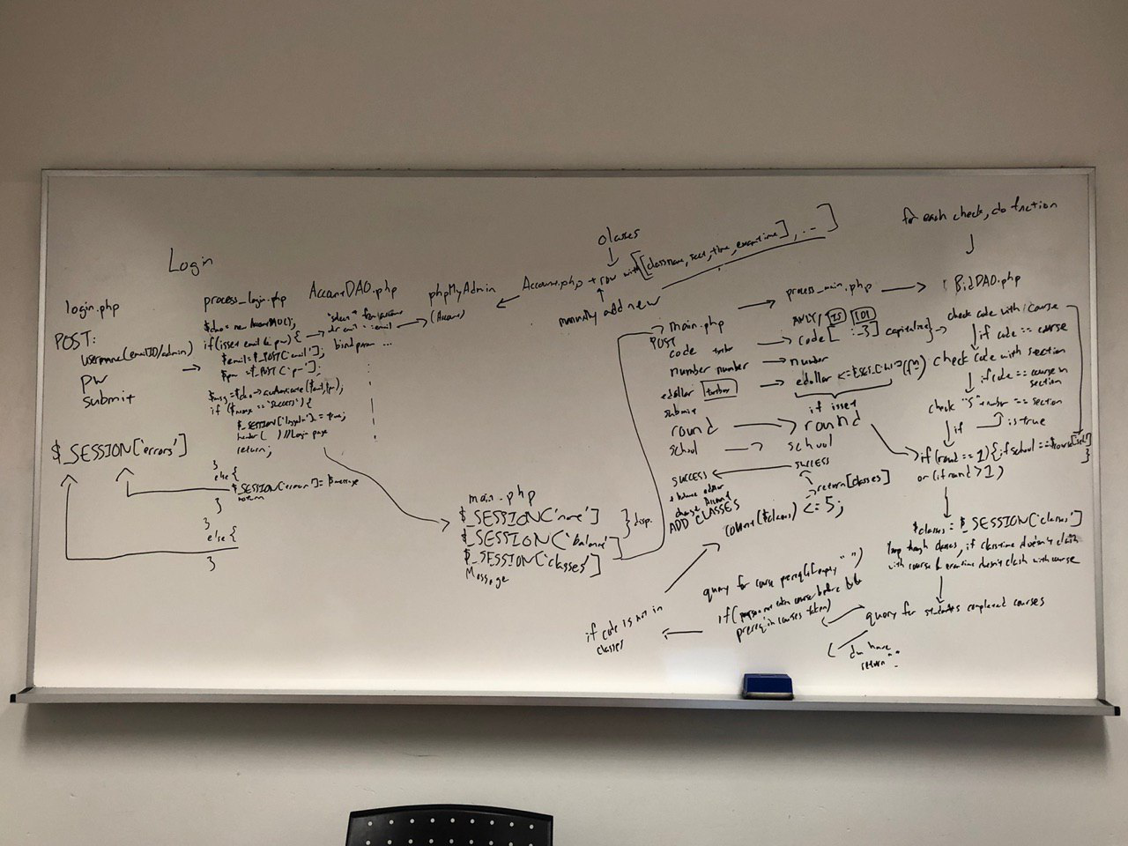

*Planning at the moment is for happy path, else will return to main.php

*Dice not considered at the moment.

Questions to raise to prof:

1. Need to check if you are able to bid 2 different courses at the same time slot (DICE)
2. How many classes are they checking out at one time?

The meeting was adjourned at 6 pm. These minutes will be circulated and adopted if there are no amendments reported in the next three days.

Prepared by,

Sonia

Vetted and edited by,

Jia ying